**Practical Work For Lesson 2 – Basic Tools**

This is a short report of the commands used for each exercises in the session (lecture 2).

**Basic Tools:**

**1. 2.**

> cd 'Programming/UCA/MSc 1 Refreshers/Basic Tools'

> mkdir lecture_1

> mv ./copyme ./lecture_1/copyme

**3.**

> cd lecture_2

> mv ./test_script.sh ./exercise/test_script.sh

**4. 5.**

> cd exercise

> touch file.1.1.1.txt

> vim file.1.1.1.txt

> cat file.1.1.1.txt

"Hello"

"Hello"

"Hello"

"world"

"world"

"*"

> less file.1.1.1.txt

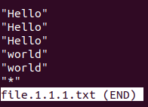

**6. 7. 8.**

> tree ~/

Command 'tree' not found, but can be installed with:

sudo snap install tree # version 1.8.0+pkg-3fd6, or

sudo apt install tree # version 1.8.0-1

See 'snap info tree' for additional versions.

> sudo apt install tree

[sudo] password for quentin:

Reading package lists... Done

Building dependency tree

Reading state information... Done

The following packages were automatically installed and are no longer required:

libfprint-2-tod1 libllvm9 python3-click python3-colorama

Use 'sudo apt autoremove' to remove them.

The following NEW packages will be installed:

tree

0 upgraded, 1 newly installed, 0 to remove and 49 not upgraded.

Need to get 43,0 kB of archives.

After this operation, 115 kB of additional disk space will be used.

Get:1 http://fr.archive.ubuntu.com/ubuntu focal/universe amd64 tree amd64 1.8.0-1 [43,0 kB]

Fetched 43,0 kB in 0s (229 kB/s)

Selecting previously unselected package tree.

(Reading database ... 196427 files and directories currently installed.

)

Preparing to unpack .../tree_1.8.0-1_amd64.deb ...

Unpacking tree (1.8.0-1) ...

Setting up tree (1.8.0-1) ...

Processing triggers for man-db (2.9.1-1) …

> tree ~/

displays the full tree of directories and files under ~/

> tree /etc > tree_folder_structure

> less tree_folder_structure

/etc

├── acpi

│   ├── asus-keyboard-backlight.sh

│   ├── asus-wireless.sh

│   ├── events

│   │   ├── asus-keyboard-backlight-down

│   │   ├── asus-keyboard-backlight-up

│   │   ├── asus-wireless-off

│   │   ├── asus-wireless-on

│   │   ├── ibm-wireless

│   │   ├── lenovo-undock

│   │   ├── thinkpad-cmos

│   │   └── tosh-wireless

│   ├── ibm-wireless.sh

│   ├── tosh-wireless.sh

│   └── undock.sh

├── adduser.conf

├── alsa

│   └── conf.d

│   ├── 10-samplerate.conf -> /usr/share/alsa/alsa.conf.d/10-samplerate.conf

│   ├── 10-speexrate.conf -> /usr/share/alsa/alsa.conf.d/10-speexrate.conf

│   ├── 50-arcam-av-ctl.conf -> /usr/share/alsa/alsa.conf.d/50-arcam-av-ctl.conf

│   ├── 50-jack.conf -> /usr/share/alsa/alsa.conf.d/50-jack.conf

│   ├── 50-oss.conf -> /usr/share/alsa/alsa.conf.d/50-oss.conf

│   ├── 50-pulseaudio.conf -> /usr/share/alsa/alsa.conf.d/50-pulseaudio.conf

│   ├── 60-upmix.conf -> /usr/share/alsa/alsa.conf.d/60-upmix.conf

│   ├── 60-vdownmix.conf -> /usr/share/alsa/alsa.conf.d/60-vdownmix.conf

│   ├── 98-usb-stream.conf -> /usr/share/alsa/alsa.conf.d/98-usb-stream.conf

│   ├── 99-pulseaudio-default.conf.example

│   └── 99-pulse.conf -> /usr/share/alsa/alsa.conf.d/pulse.conf

├── alternatives

**Zip files:**

**9.** vim is used; zip is already installed

**10.**

> wget http://download.geonames.org/export/zip/FR.zip

--2020-09-24 15:13:36-- http://download.geonames.org/export/zip/FR.zip

Resolving download.geonames.org (download.geonames.org)... 188.40.33.19

Connecting to download.geonames.org (download.geonames.org)|188.40.33.19|:80... connected.

HTTP request sent, awaiting response... 200 OK

Length: 656006 (641K) [application/zip]

Saving to: ‘FR.zip’

FR.zip 100%[============>] 640,63K 820KB/s in 0,8s

2020-09-24 15:13:44 (820 KB/s) - ‘FR.zip’ saved [656006/656006]

> ls

file.1.1.1.txt FR.zip test_script.sh tree_folder_structure

> unzip FR.zip -d ./

Archive: FR.zip

inflating: ./readme.txt

inflating: ./FR.txt

> less FR.zip

Archive: FR.zip

Length Method Size Cmpr Date Time CRC-32 Name

-------- ------ ------- ---- ---------- ----- -------- ----

2734 Defl:N 1116 59% 2020-09-24 03:22 542665e1 readme.txt

5342316 Defl:N 654652 88% 2020-09-24 03:22 bda7faba FR.txt

-------- ------- --- -------

5345050 655768 88% 2 files

Less <file>.zip seems to describe the content of the .zip file without having to extract

its content. It is likely accessing a registry of the .zip content.

> rm -f FR.zip

**11.**

> less FR.txt

This file seems to contain tabular data. Which is proven by opening the readme.txt

> less readme.txt

Contains a description of the file: “This readme describes the GeoNames Postal Code

dataset.

The main GeoNames gazetteer data extract is here:

http://download.geonames.org/export/dump/”

“The data format is tab-delimited text in utf8 encoding, with the following fields :

country code : iso country code, 2 characters

postal code : varchar(20)

place name : varchar(180)

admin name1 : 1. order subdivision (state) varchar(100)

admin code1 : 1. order subdivision (state) varchar(20)

admin name2 : 2. order subdivision (county/province) varchar(100)

admin code2 : 2. order subdivision (county/province) varchar(20)

admin name3 : 3. order subdivision (community) varchar(100)

admin code3 : 3. order subdivision (community) varchar(20)

latitude : estimated latitude (wgs84)

longitude : estimated longitude (wgs84)

accuracy : accuracy of lat/lng from 1=estimated, 4=geonameid, 6=centroid of

addresses or shape”

**12.**

> grep -rnw ./FR.txt -e '01000'

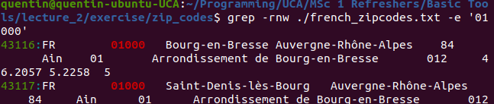

**13.**

> grep -rnw ./FR.txt -e 'Nice' > nice.txt

> wc -l nice.txt

231 nice.txt

**Files administration:**

**14.**

> mv ./FR.txt ./french_zipcodes.txt

**15.**

> ls -l french_zipcodes.txt

-rw-rw-r-- 1 quentin quentin 5342316 sept. 24 03:22 french_zipcodes.txt

**16.**

> chmod u+rwx french_zipcodes.txt

> chmod u-x french_zipcodes.txt

> chmod u-w french_zipcodes.txt

**17.**

> chmod u=rwx,g=r,o-r french_zipcodes.txt

**18.**

> chmod g=r '/Programming/UCA/MSc 1 Refreshers/Basic Tools/lecture_2/exercise'

> chmod g=r french_zipcodes.txt

For the group users to delete the file, we need to give write access to the directory to

group users

**Shell Script:**

**19.**

> hello=”Hello World!”

> echo $hello

Hello World!

**20.**

> LONG_FILES_LIST="ls"

> $LONG_FILES_LIST

file_err.txt msg_err.sh user_reply.txt

hello.sh other_files zip_codes

> cd ..

> cd ..

> cd lecture_1

> $LONG_FILES_LIST

copyme

**21.**

> read -p "What is your name? " user_name; echo "$user_name" > user_reply.txt

What is your name? Quentin

**22.**

> vim hello.sh

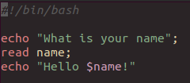

> chmod u+w hello.sh

> ./hello.sh

**23.**

> vim msg_err.sh



> chmod u+x ./msg_err.sh

> ./msg_err.sh "file_err.txt"

Normal Message

> vim file_err.txt



**24.**

> touch testfile.txt

> mkdir testfolder

> vim copy.sh

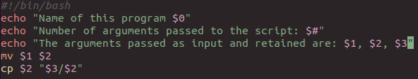

> chmod u+x copy.sh

> ./copy.sh testfile.txt renamedtestfile.txt testfolder

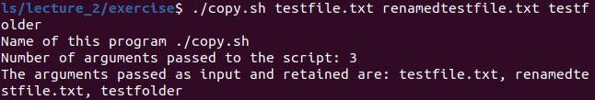

> ls



> cd testfolder

> ls



**25.**

> vim create50.sh

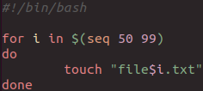

> chmod u+x create50.sh

> ./create50.sh

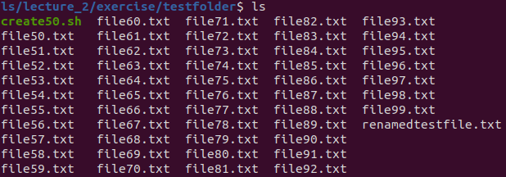

**26.**

> rm $(ls | grep -P "^file[5-9][0-9]*")

> ls



**27.a**

> vim file_maker.sh

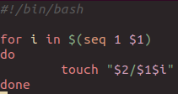

> chmod u+x file_maker.sh

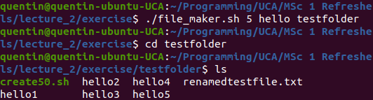

**27.b**

> vim file_renamer.sh

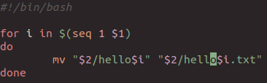

> chmod u+x file_renamer.sh

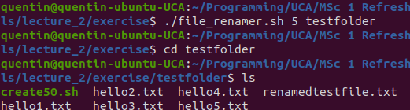

**27.c**

> vim file_mover.sh

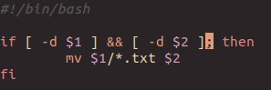

> chmod u+x file_mover.sh

> cd testfolder

> mkdir secondtestfolder

> cd ..

> ./file_mover.sh ./testfolder ./testfolder/secondtestfolder

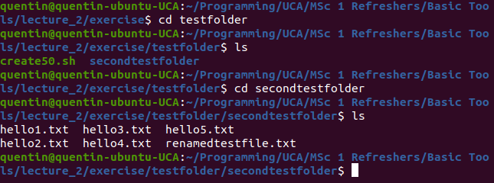

**Notes Taken Before The Practical Work**

> cd 'Programming/UCA/MSc 1 Refreshers/Basic Tools/lecture_2'

> ls -l

-rw-rw-r-- 1 quentin quentin 439137 sept. 24 13:15 'Lecture_2_Basic tools.pdf'

-rw-rw-r-- 1 quentin quentin 108 sept. 24 13:44 practical_work.txt

> touch test_file.txt

> vim test_file.txt

Wrote some stuff

> ls -la

drwxrwxr-x 2 quentin quentin 4096 sept. 24 13:51 .

drwxrwxr-x 3 quentin quentin 4096 sept. 24 13:43 ..

-rw-rw-r-- 1 quentin quentin 439137 sept. 24 13:15 'Lecture_2_Basic tools.pdf'

-rw-rw-r-- 1 quentin quentin 88 sept. 24 13:51 .~lock.practical_work.txt#

-rw-rw-r-- 1 quentin quentin 396 sept. 24 13:51 practical_work.txt

-rw-rw-r-- 1 quentin quentin 84 sept. 24 13:49 test_file.txt

> chmod o+w 'test_file.txt'

> ls -l

-rw-rw-r-- 1 quentin quentin 439137 sept. 24 13:15 'Lecture_2_Basic tools.pdf'

-rw-rw-r-- 1 quentin quentin 396 sept. 24 13:51 practical_work.txt

-rw-rw-rw- 1 quentin quentin 84 sept. 24 13:49 test_file.txt

> chmod o-r 'test_file.txt'

> myVar="Hello World!"

> echo $myVar

Hello World!

> read user_name

Quentin

> read -p "What is your name?" other_user_name

What is your name?Quentin

> echo $user_name

Quentin

> echo $other_user_name

Quentin

> myVar="a"

> case $myVar in "a")

> echo "a"

> ;;

> "b")

> echo "b"

> ;;

> esac

a

> [ 2 -eq 3 ] && echo "smth"

> [ 2 -eq 3 ] || echo "smth"

smth

> echo $( 3 + 2 )

3: command not found

> echo $(( 3 + 2 ))

5

> x=1;y=0

> [ ! $x -eq 1 ] || echo "number is not null"

number is not null

> myfunc()

> {

> echo "myfunc was called as: $@"

> x=2

> }

> x=1

> echo "x is $x"

x is 1

> myfunc 1 2 3

myfunc was called as: 1 2 3

> touch test_script.sh

> vim test_script.sh

> chmod a+x test_script.sh

> ./test_script.sh "HELLO" 10

HELLO 1 time

HELLO 2 time

HELLO 3 time

HELLO 4 time

HELLO 5 time

HELLO 6 time

HELLO 7 time

HELLO 8 time

HELLO 9 time

HELLO 10 time